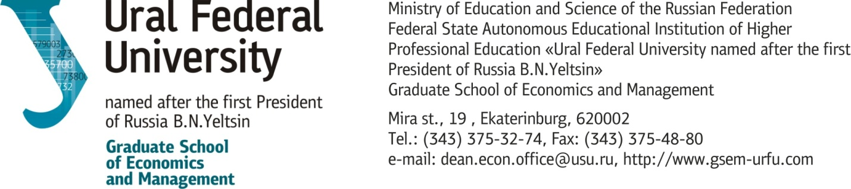

Dd/mm/yy, Ekaterinburg

Recommendation Letter

